ESSD AI Competition - Week 2

Deliverables
At the end of week two, teams must submit:
- The original un-cleaned data source
  - Original is located under Data/Original Dataset
- The cleaned dataset with at least 3 new engineered features in csv and json format
  - Cleaned data is under Data/Cleaned Dataset
- A data dictionary that explains each feature, format, and context for each data source
  - Please see the README.md
- Any cleaning scripts used with citations in comments for sections generated with AI
  - All scripts were generated using Copilot. We used Copilot because it could handle a full year’s worth of data from three locations along the Yakima River without crashing or telling me the files were too large.
- Your selected ML Algorithms with 1-2 sentences justifying your choices
  - We choose to use random forest as our Machine Learning model, because it can deal with complex non-linear relationships between predictors and the response variable and it does not need any data distribution assumptions. Also, random forest is faster to train compared to other Machine Learning models such as deep learning.
- A requirements.txt containing python environment dependencies
  - Requirements.txt files are uploaded to the branch.
- A brief paragraph describing data preparation approach, including:
  - A description of data cleaning, normalization, and feature engineering steps
  - The role of AI at each step

We directly prompted Copilot to clean my original data by having it remove extraneous data from the original data files, keeping only the time and value columns, then correct time values to datetime values. Afterwards, We had Copilot remove duplicate timestamps and missing data values. Finally, the data was sorted chronologically. Once the data was clean, it was normalized by only comparing data to find matching timestamps, removing unmatched data, and merging everything into one file. For feature engineering, the cleaned and merged data was aligned for hourly sampling, derivatives were calculated, high water events were detected, and a training matrix was computed. The initial training matrix was augmented to better provide high water warnings, then the models were retrained to test different water rule variants. All of this was done in Copilot, then tested using Python in VS Code.

Submission Template
In your team folder you should have the following file structure:
- Data/
  - Contains the original and cleaned dataset both clearly labeled, and your data dictionary in json format
- Scripts/
  - Contains all scripts used for cleaning clearly labeled
- requirements.txt
- README.md
  - Documents your model selection, data dictionary table, data preparation paragraph

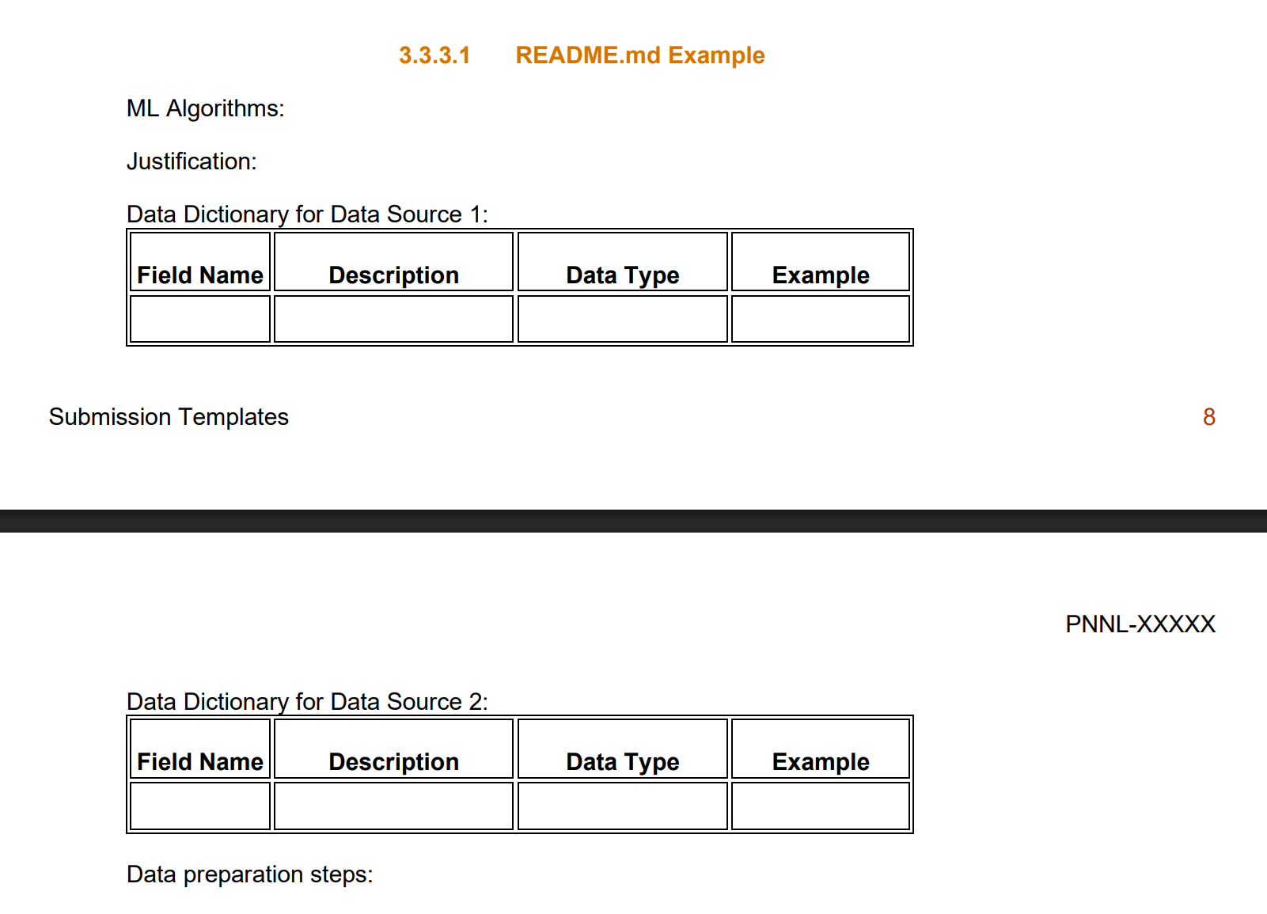
Field | Description | Data Type | Example
Gauge height | Water level at the gauge station (ft) from 2025 | Numerical | 15 ft
Upstream discharge | The total volume of water from upstream (cubic ft/s) from 2025 | Numerical | 3,000 cubic ft/s

